**Name: SALINI K.B**

**Roll No:33**

**Batch:MCA B**

**Date:8-4-2022**

**NETWORKING & SYSTEM ADMINISTRATION LAB**

**Experiment No.: 3**

**Aim**

To familiarize DDL Commands- ALTER,DROP,TRUNCATE,RENAME

**Procedure**

**Questions**

1.Create a table emp1 with attributes empno number(4)as primary key, ename char(10),hiredate,  salary, commission

insert 5 rows of data

CREATE DATABASE EMP;

CREATE TABLE emp1(EMPNO INT(4) PRIMARY KEY, ENAME CHAR(10), HIREDATE DATE, SALARY INT(5),COMMISSION INT(5));

INSERT INTO emp1(EMPNO,ENAME,HIREDATE,SALARY) VALUES (101,'RAMESH','1980-01-17',5000),

(102,'AJAY','1985-07-05',5000),

(103,'RAVI','1981-08-12',1500),

(104,'Nikesh','1983-03-03',3000),

(105,'Ravi','1985-07-05',3000);

SELECT * FROM emp1;

**Output Screenshot**

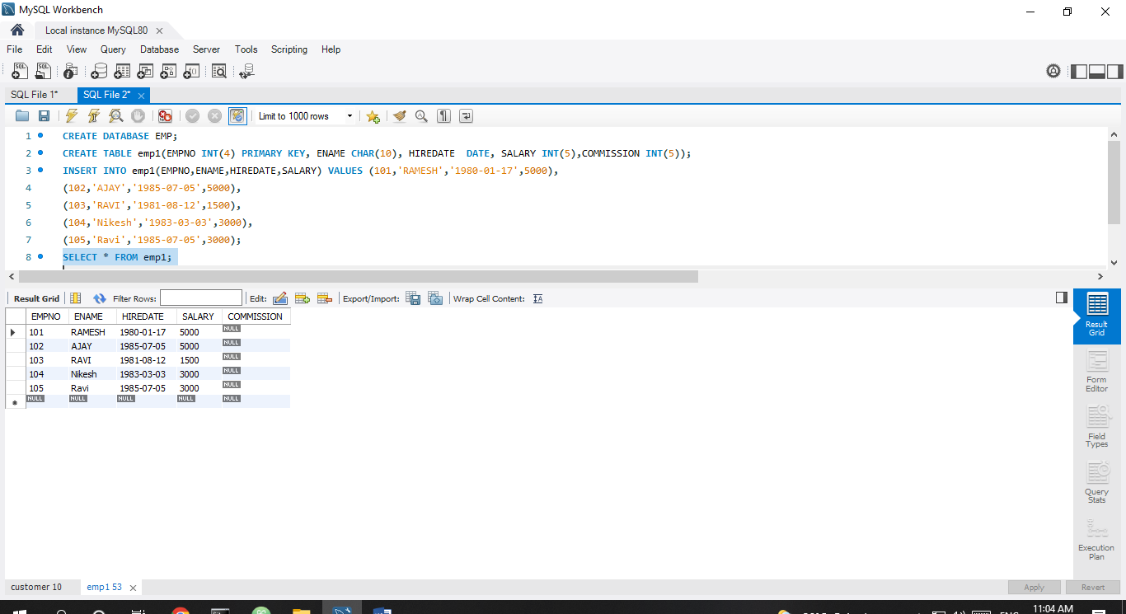

2.Modifying the structure of tables

a.Add new columns: sal number(7,2)

SELECT * FROM emp1;

ALTER TABLE emp1 ADD sal int;

SELECT * FROM emp1;

**Output Screenshot**

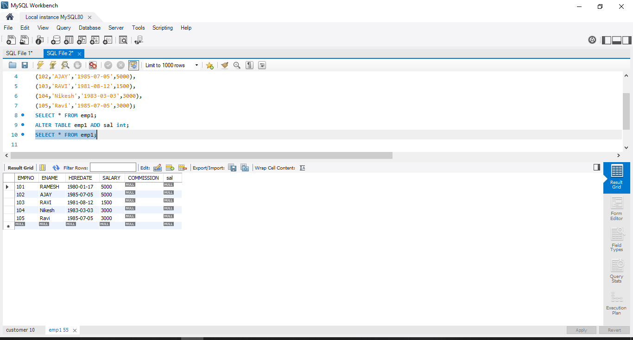

b.Dropping a column from a table: sal

ALTER TABLE emp1 DROP COLUMN sal;

select * from emp1;

**Output Screenshot**

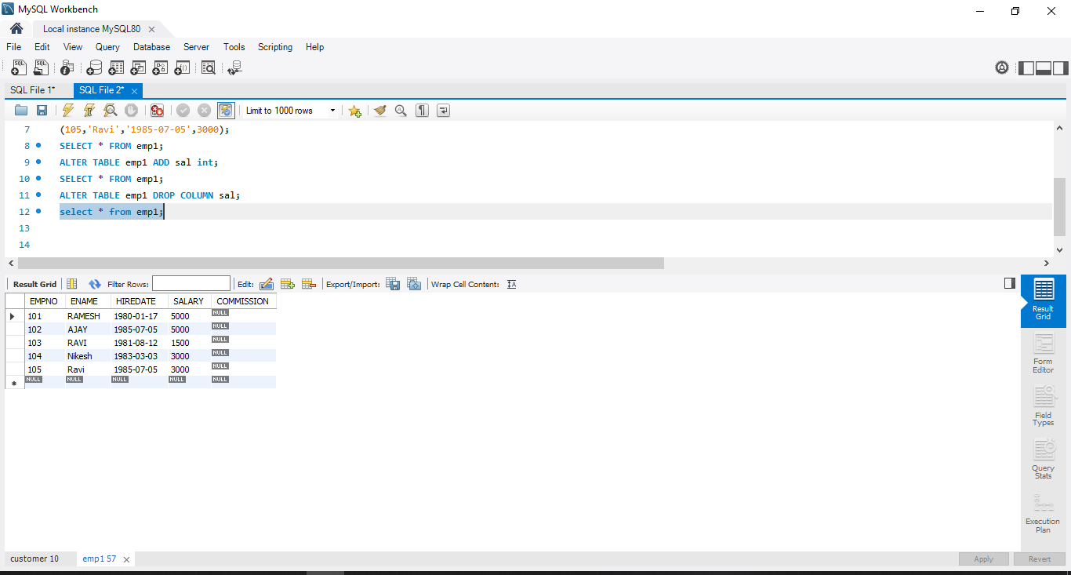

c.Modifying existing column :ename varchar2(15)

ALTER TABLE emp1 MODIFY ename VARCHAR(15);

select * from emp1;

**Output Screenshot**

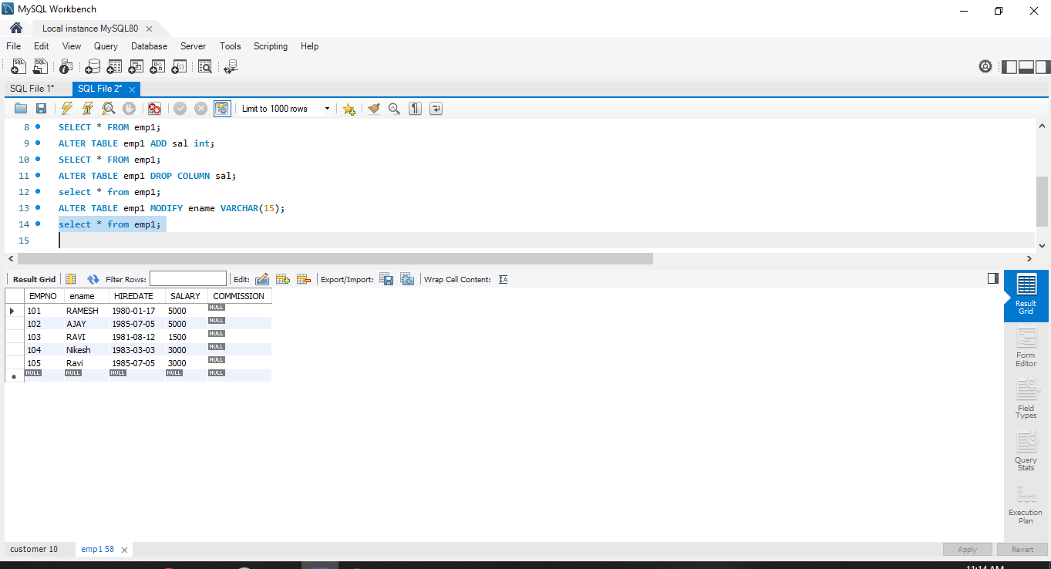

d.Renaming the tables: emp1 to emp2

RENAME table emp1 to emp2;

select * from emp2;

**Output Screenshot**

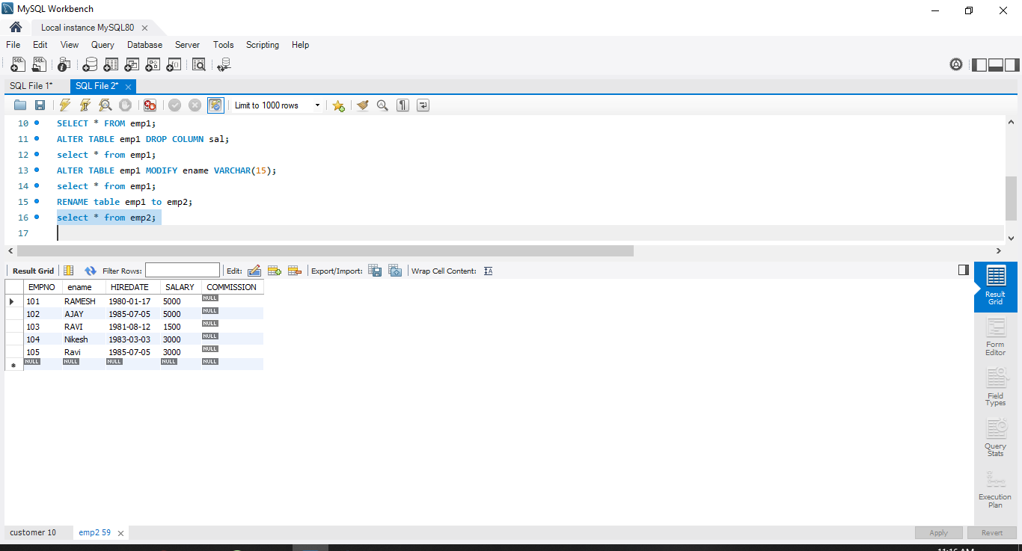

e.truncating the tables:emp2

TRUNCATE TABLE emp2;

select * from emp2;

**Output Screenshot**

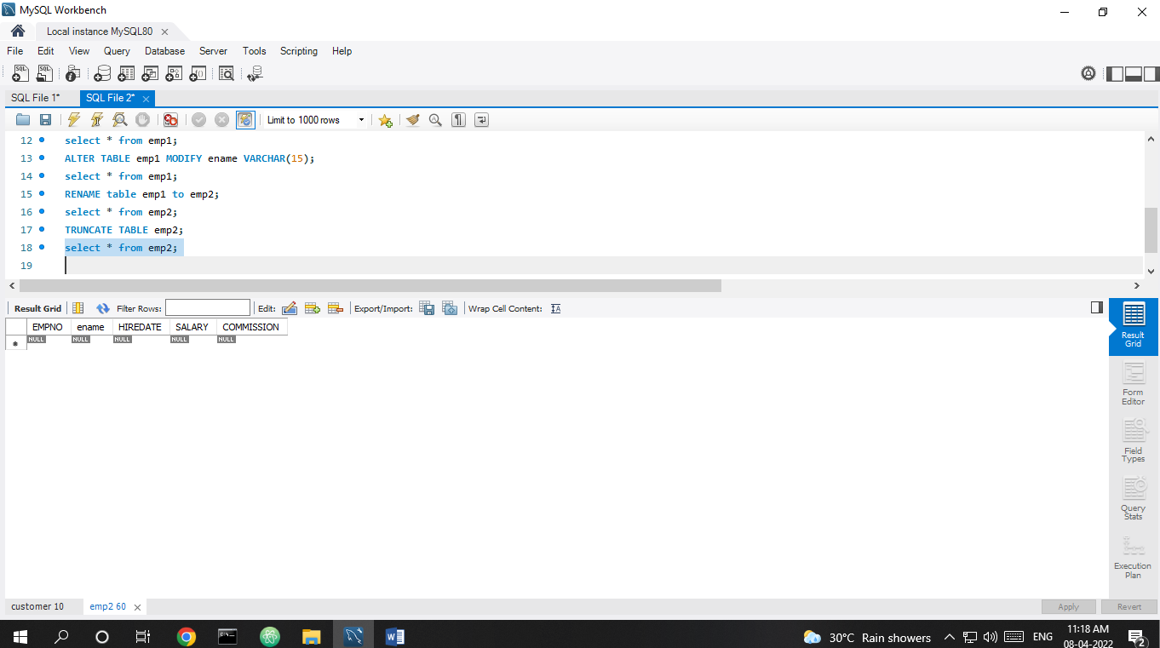

f. Destroying tables:emp

DROP TABLE emp2;

**Output Screenshot**



3.Create a table stud with sname varchar2(20) primary key , rollno number(10) not null,dob  date not null

CREATE TABLE stud(sname varchar(20) PRIMARY KEY, rollno int NOT NULL, dob date NOT NULL);

select * from stud;

**Output Screenshot**

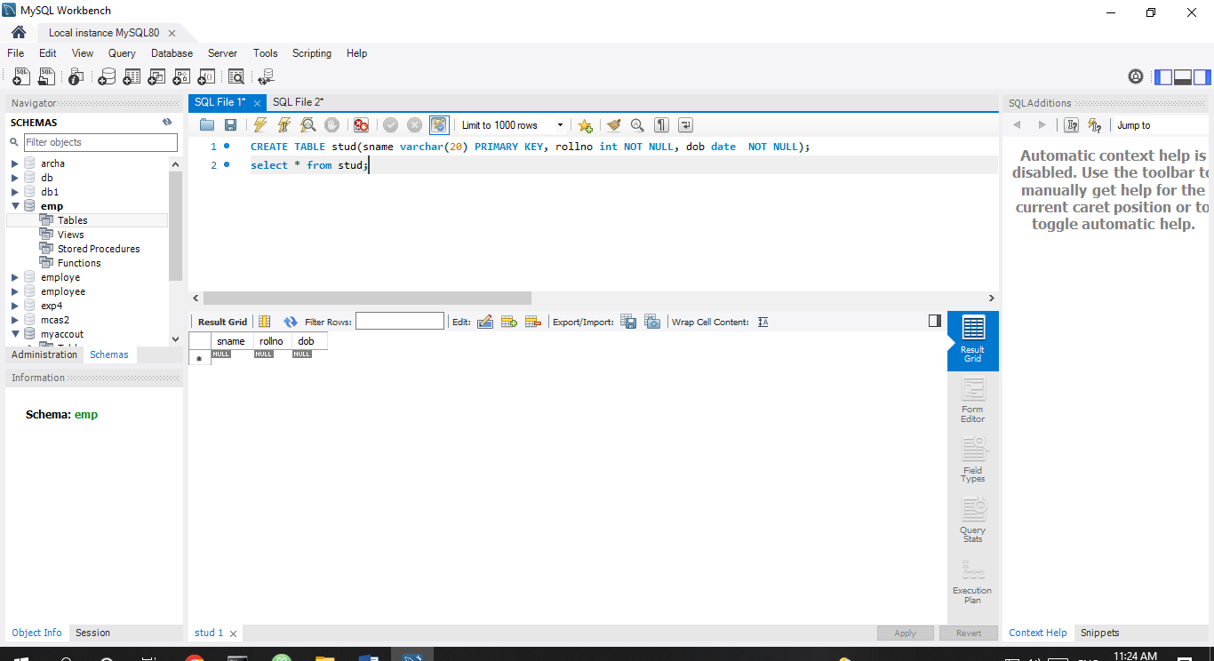

4.Create a table student as regno number (6), mark number (3) check constraint (mark >=0 and  mark

<=100));

Create table student (regno int, mark int(3) constraint b check (mark >=0 and mark <=100));

SELECT * from student;

**Output Screenshot**

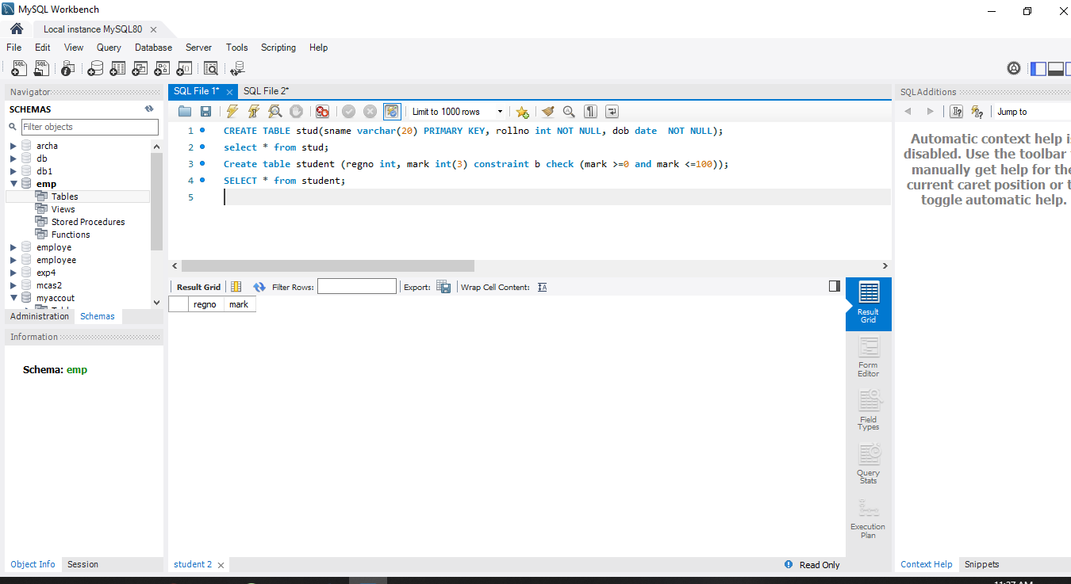

5.Create a table cust with(custid number(6) constraint unique, name char(10)

create table cust(custid int(6) primary key, name char(10));

select * from cust;

**Output Screenshot**

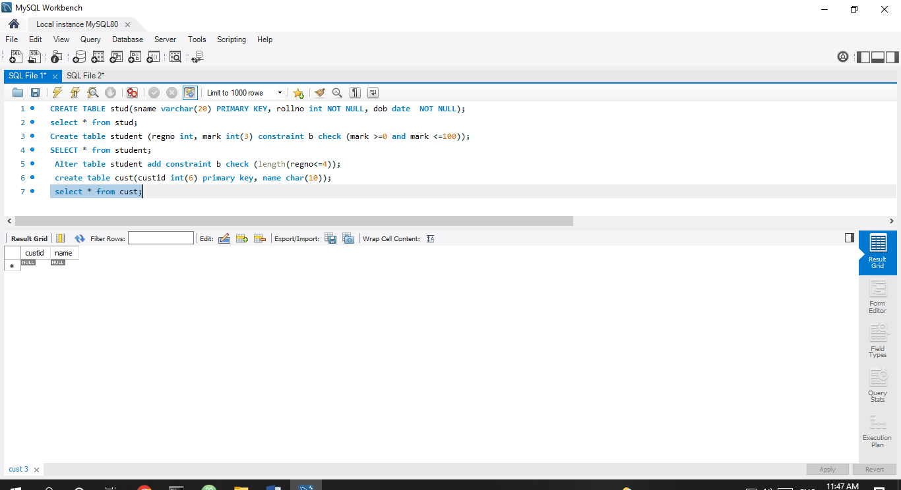

**Output Screenshot**

CREATE TABLE stud(sname varchar(20) PRIMARY KEY, rollno int NOT NULL, dob date NOT NULL);

select * from stud;

Create table student (regno int, mark int(3) constraint b check (mark >=0 and mark <=100));

SELECT * from student;

Alter table student add constraint b check (length(regno<=4));

create table cust(custid int(6) primary key, name char(10));

select * from cust;

